DSP_DNS_Book

Michał Lesiowski

2024-09-23

Table of contents

# Preface

This is a Quarto book.

To learn more about Quarto books visit <https://quarto.org/docs/books>.

1 + 1

[1] 2

13 / 3

[1] 4.333333

Test test 123 i inny test

# Wprowadzenie

## Cel dokumentu

## Zakres systemu

## Definicje, akronimy, skróty

## Dokumenty referencyjne

## Odbiorcy dokumentu

|  |
| --- |
| Uwaga |
| To jest przykładowy callout w sekcji bocznej. |

|  |  |  |
| --- | --- | --- |
| This is a template for a simple Quarto book output to html, PDF or docx format. It includes a GitHub Action that will build the website automatically when you make changes to the files. The NOAA palette and fonts has been added to theme.scss. The webpage will be on the gh-pages branch. Serving the website files from this branch is a common way to keep all the website files from cluttering your main branch | This is a template for a simple Quarto book output to html, PDF or docx format. It includes a GitHub Action that will build the website automatically when you make changes to the files. The NOAA palette and fonts has been added to theme.scss. The webpage will be on the gh-pages branch. Serving the website files from this branch is a common way to keep all the website files from cluttering your main branch | This is a template for a simple Quarto book output to html, PDF or docx format. It includes a GitHub Action that will build the website automatically when you make changes to the files. The NOAA palette and fonts has been added to theme.scss. The webpage will be on the gh-pages branch. Serving the website files from this branch is a common way to keep all the website files from cluttering your main branch |

This is a template for a simple Quarto book output to html, PDF or docx format. It includes a GitHub Action that will build the website automatically when you make changes to the files.

This is a template for a simple Quarto book output to html, PDF or docx format. It includes a GitHub Action that will build the website automatically when you make changes to the files.

Fruit prices

| fruit | price |
| --- | --- |
| apple | 2.05 |
| pear | 1.37 |
| orange | 3.09 |

### Grid tables

Bardziej zaawansowany typ np dodatkowe paragrafy, bloki kodu, listy

| Fruit | Price | Advantages |
| --- | --- | --- |
| Bananas | $1.34 | * built-in wrapper * bright color |
| Oranges | $2.10 | * cures scurvy * tasty |

## Link do 2 pages

intro

## Funckje jakie oczekuje od końcowego rozwiązania:

* Output do: PDF, DOCX, HTML
* Github Actions that will build website automatically when I make changes to the files
* Obsługa diagramów
* Konfigruacja pełna layoutu np. wygląd, czcionki poprzez theme.csss
* Templates dla

# 1. Introduction

This is a book created from markdown and executable code.

See Knuth (1984) for additional discussion of literate programming.

1 + 1

[1] 2

## 1.1 Interactivity Test

## 1.2 Test cross reference

See Figure 1.2 for an illustration

Skocz do koniec

## 1.3 Test list of figures

## 1.4 Rozdział kolejny

Test

| Col1 | Col2 | Col3 |
| --- | --- | --- |
| 1 | 2 | 3 |
| 1 | 2 | 3 |
| 3 | 3 | 3 |

## 1.5 Test sekcji

Poniżej RAW content z HTML

## 1.6 Rozdział drugi

Drugi rozdział

### 1.6.1 Trzeci podrozdział

Trzeci itd.. You can also do this on a per-format basis (if for example you want to provide a higher resolution image for EPUB and a lower resolution image for HTML to reduce download time). For example:

By “right format”, we mean that the data is tidy, and ready to be summarised and graphed.

Quarto Pub is a free publishing service for content created with Quarto. Quarto Pub is ideal for blogs, course or project websites, books, presentations, and personal hobby sites.

It’s important to note that all documents and sites published to Quarto Pub are publicly visible. You should only publish content you wish to share publicly.

|  |
| --- |
| Caution |
| Tu znajduje się zwijana sekcja w boxie callout typu caution |

|  |
| --- |
| Tip |
| Altair is based on Vega-Lite, a high-level grammar of interactive graphics |

Właściwe linki i tu przykładowy odnośnik do mojej [[books]] książek

|  |
| --- |
| Note |
| A tu znajduje się callout note |

Cytacik lub wcięcie takie coś…

If you haven’t published to Quarto Pub before, the publish command will prompt you to authenticate. After confirming that you want to publish, your content will be rendered and deployed, and then a browser opened to view your site.

A jeśli chcemy umieścić kod to możemy to zrobić przy użyciu takiej dyrektywy jak poniżej. Może być ona też zwijana i rozwijana. To się określa w konigu yaml/

library(tidyverse)  
penguins <- read.csv('https://raw.githubusercontent.com/rfordatascience/tidytuesday/master/data/2020/2020-07-28/penguins.csv')%>%  
 drop_na()  
head(penguins)

species island bill_length_mm bill_depth_mm flipper_length_mm body_mass_g  
1 Adelie Torgersen 39.1 18.7 181 3750  
2 Adelie Torgersen 39.5 17.4 186 3800  
3 Adelie Torgersen 40.3 18.0 195 3250  
4 Adelie Torgersen 36.7 19.3 193 3450  
5 Adelie Torgersen 39.3 20.6 190 3650  
6 Adelie Torgersen 38.9 17.8 181 3625  
 sex year  
1 male 2007  
2 female 2007  
3 female 2007  
4 female 2007  
5 male 2007  
6 female 2007

We’ve removed missing values here, which means that the data has 333 rows now[^1]. Ten indeks górny przypis ^1 coś nie chce zabanglać

If you have an existing Quarto Pub site that you want to publish to, you should manually create a _publish.yml file that looks like the example above, but with the appropriate id and url values for your site.

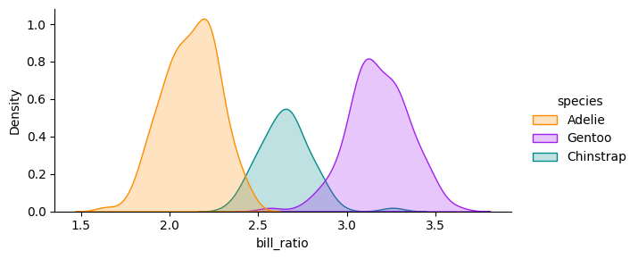

Właściwy opis wykresu

### 1.6.2 Podział na dwie kolumny

Poniżej demo jak podzielić przestrzeń na 2 kolumny

|  |  |  |
| --- | --- | --- |
| |  | | --- | | Figure 1.1: Właściwy opis wykresu | |  |

|  |  |
| --- | --- |
| |  | | --- | | Figure 1.2: Właściwy opis wykresu | |

The average bill length is 43.9927928 mm and the average bill depth is 17.1648649 mm.

The data was collected between 2007 and 2009

### 1.6.3 Zewnętrzne źródło

|  |
| --- |
| Figure 1.3: Elephant |

### 1.6.4 Dyrektywa na całą szerokość

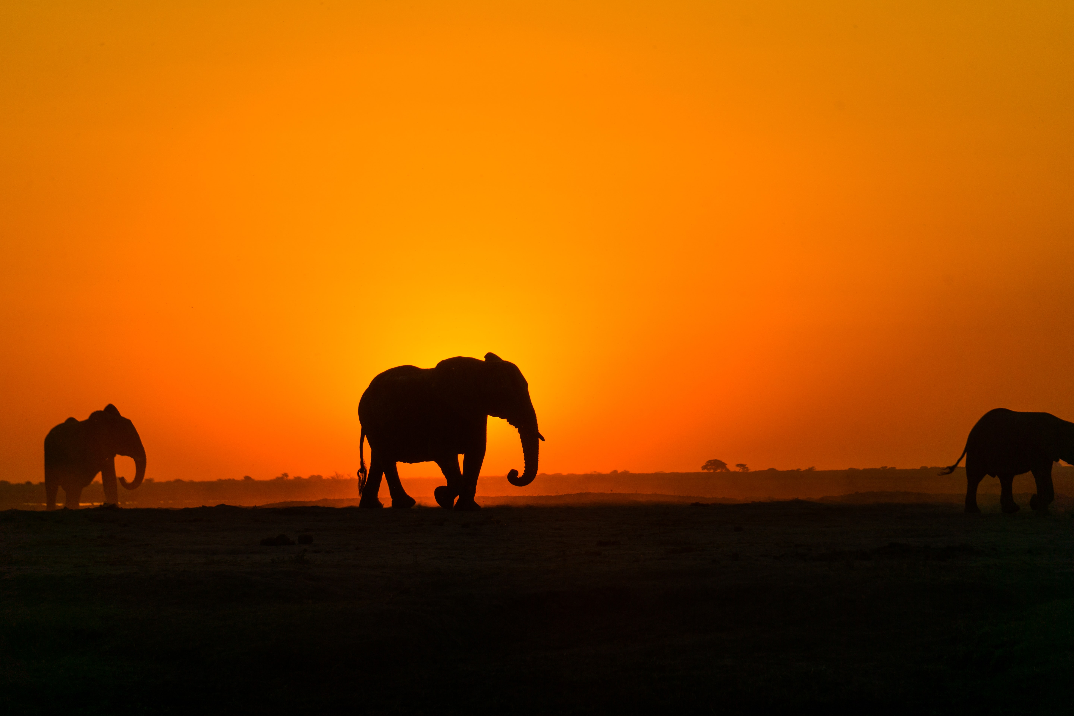

### 1.6.5 Dyrektywa na całe okno



A full screen image

Dodatkowo szerokości

knitr::kable(  
 mtcars[1:6, 1:10]  
)

|  | mpg | cyl | disp | hp | drat | wt | qsec | vs | am | gear |
| --- | --- | --- | --- | --- | --- | --- | --- | --- | --- | --- |
| Mazda RX4 | 21.0 | 6 | 160 | 110 | 3.90 | 2.620 | 16.46 | 0 | 1 | 4 |
| Mazda RX4 Wag | 21.0 | 6 | 160 | 110 | 3.90 | 2.875 | 17.02 | 0 | 1 | 4 |
| Datsun 710 | 22.8 | 4 | 108 | 93 | 3.85 | 2.320 | 18.61 | 1 | 1 | 4 |
| Hornet 4 Drive | 21.4 | 6 | 258 | 110 | 3.08 | 3.215 | 19.44 | 1 | 0 | 3 |
| Hornet Sportabout | 18.7 | 8 | 360 | 175 | 3.15 | 3.440 | 17.02 | 0 | 0 | 3 |
| Valiant | 18.1 | 6 | 225 | 105 | 2.76 | 3.460 | 20.22 | 1 | 0 | 3 |

## 1.7 Koniec dokumentu

### 1.7.1 Koniec strony

Przed przerwą

Umieszczamy informacje takie a takie

# 2. Document - Sample 1

Software Requirements Specification

1. Metryka
   1. Tytuł
   2. Logo/ Unikalny numer / Wersja dokumentu (wersja z Github?)
   3. Data utworzenia / Data modyfikacji
   4. Authors (Tabela: Name, Role, Department)
   5. Historia dokumentu (Tabela: Data, Wersja, Revision Description, Revision Author)
   6. Approvals (może na końcu tabela: Approval date, Approved Version, Approver Role, Approver)
2. Introduction
   1. Cel projektu (purpose of project)
   2. Definicje, akronimy, skróty, słownik (Terms, Acronyms and Definitions)
   3. Odnośniki i powiązane dokumenty (Related documents)
   4. Instrukcja obsługi (opcja)
3. Opis systemu
   1. Zakres (Scope)
      1. Funkcjonalności z zakresie (In Scope Functionality)
      2. Poza zakresem (Out of Scope Functionality)
   2. Kontekst systemu - Opis systemu, jak system będzie wpasowany w otoczenie, interakcje z innymi systemami
4. Goals
5. Functional Requirements
6. Non-functional requirements
7. User Stories
8. Wireframes
9. Acceptance Criteria
10. Rules
11. Assumptions and Constraints

RACI? co jeszcze, tabele - User Stories,

Makiety - opis tabelki do tego,

Lightbox

Test GIT i jak katalog tych dokumentów

# 3. Tables

## 3.1 Tables

Poniżej znajdują się przykładowe tabele. Zerknij

### 3.1.1 Markdown Tables

Ten tekst jest formatowany przez CSS i jest

|  |  |  |  |  |  |  |  |  |  |  |  |  |  |  |  |  |
| --- | --- | --- | --- | --- | --- | --- | --- | --- | --- | --- | --- | --- | --- | --- | --- | --- |
| | Default | Left | Right | Center | | --- | --- | --- | --- | | 12 | 12 | 12 | 12 | | 123 | 123 | 123 | 123 | | 1 | 1 | 1 | 1 |   Table 3.1: My Caption |

When reviewing a document you often want to provide inline comments with suggested revisions. This is possible in Quarto using HTML comments (which are ignored by all output formats). Visual mode includes a command for inserting HTML comments as well as special highlighting treatment to easily parse out editing comments from surrounding text. No text.

## 3.2 See

Zobacz tu cross reference -> Table 3.1

**Historia zmian**

|  |  |  |  |  |  |  |  |  |  |  |  |  |  |  |  |  |
| --- | --- | --- | --- | --- | --- | --- | --- | --- | --- | --- | --- | --- | --- | --- | --- | --- |
| | Data zmiany | Wersja dokumentu | Kto zmienił | Opis zmiany | | --- | --- | --- | --- | | 08.11.2023 | 1.0 | Michał Lesiowski | Utworzenie dokumentu | | 01.03.2024 | 1.1 | Michał Lesiowski | Aktualizacja - słownik konfigurator, podgląd zgłoszenia (przycisk edycja), powiadomienia o akcji | | 06.05.2024 | 1.2 | Michał Lesiowski | Aktualizacja makiet, Baza zgłoszeń mechanizm edycja/zapisz, dodanie szablonów email do wysyłki informacji z podglądu zgłoszenia - raport wstępny, raport końcowy. |   Table 3.2: Historia wersji dokumentu |

Powyższa tabela mogłaby zaciągać informacje z Commit w te miejsca oraz numery wersji

# 4. Galery

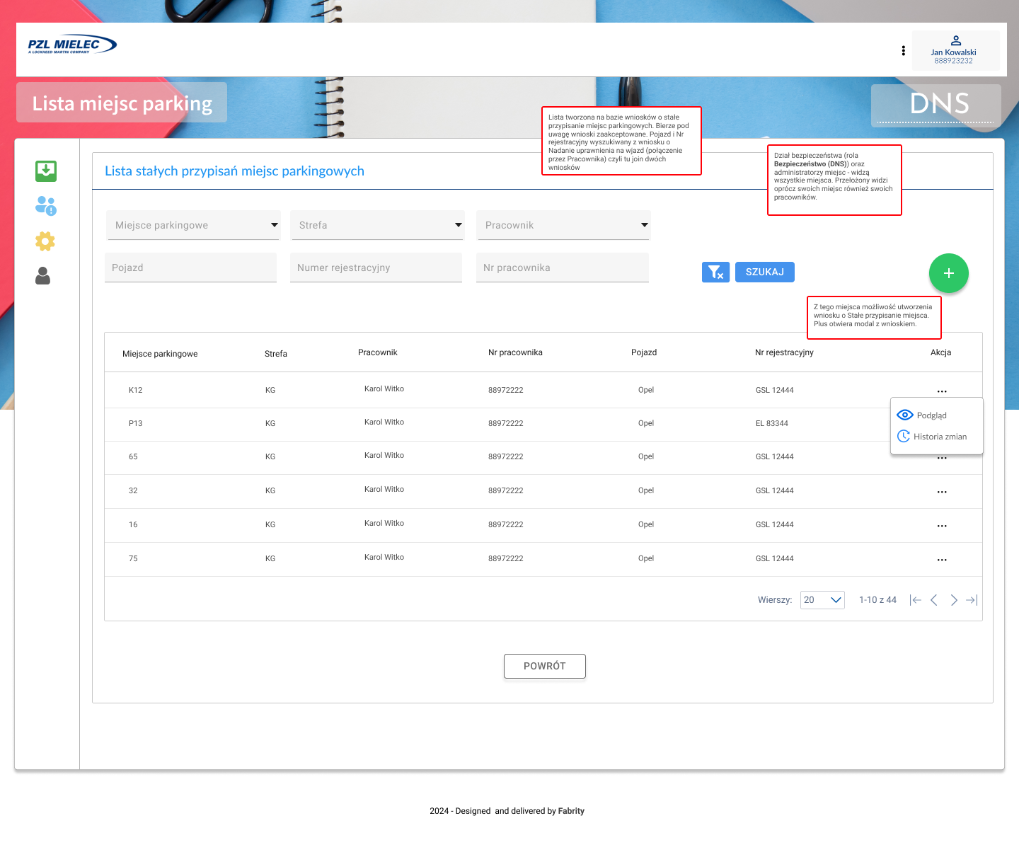{#fig-elephant} 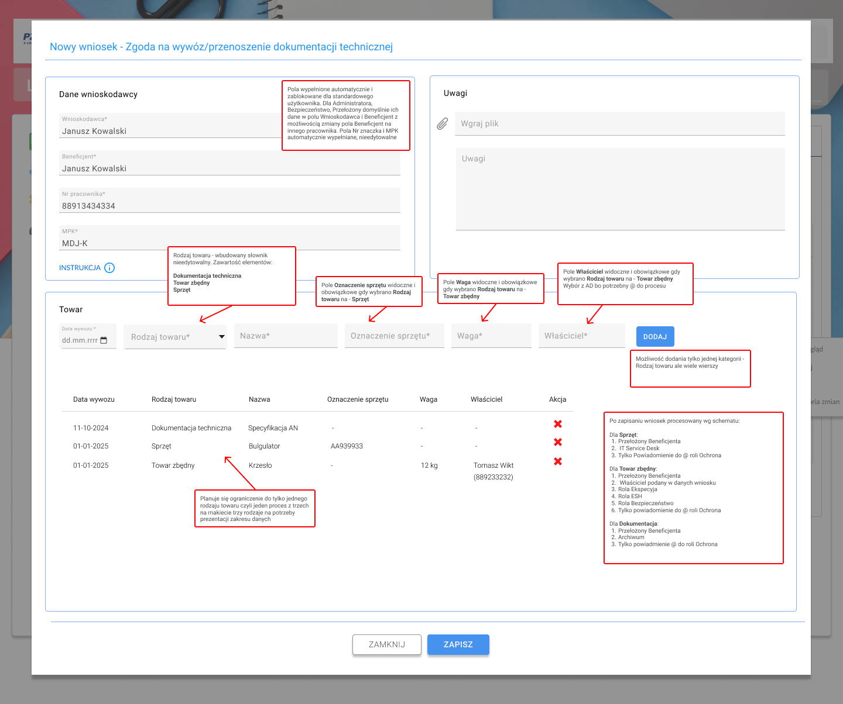 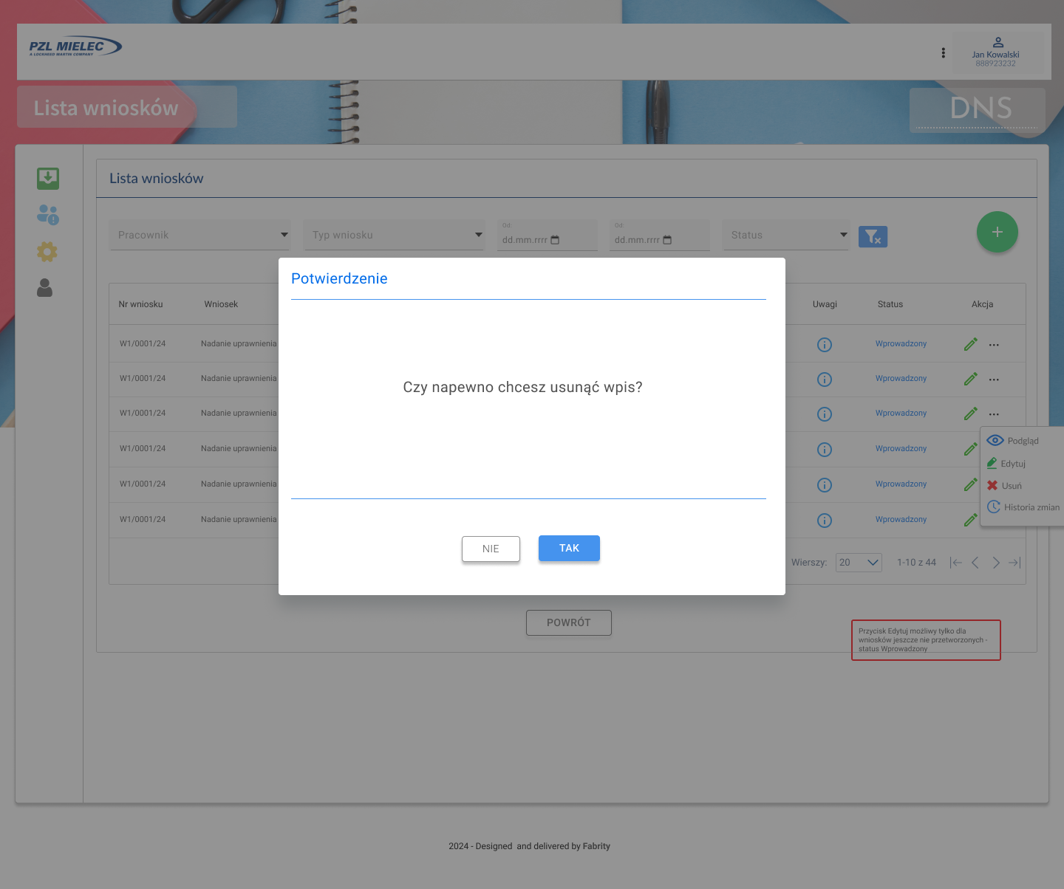

# 5. Example Lightbox Document

## 5.1 Chilmark

Here is a simple image with a description. This also overrides the description position and places it to the left of the image.

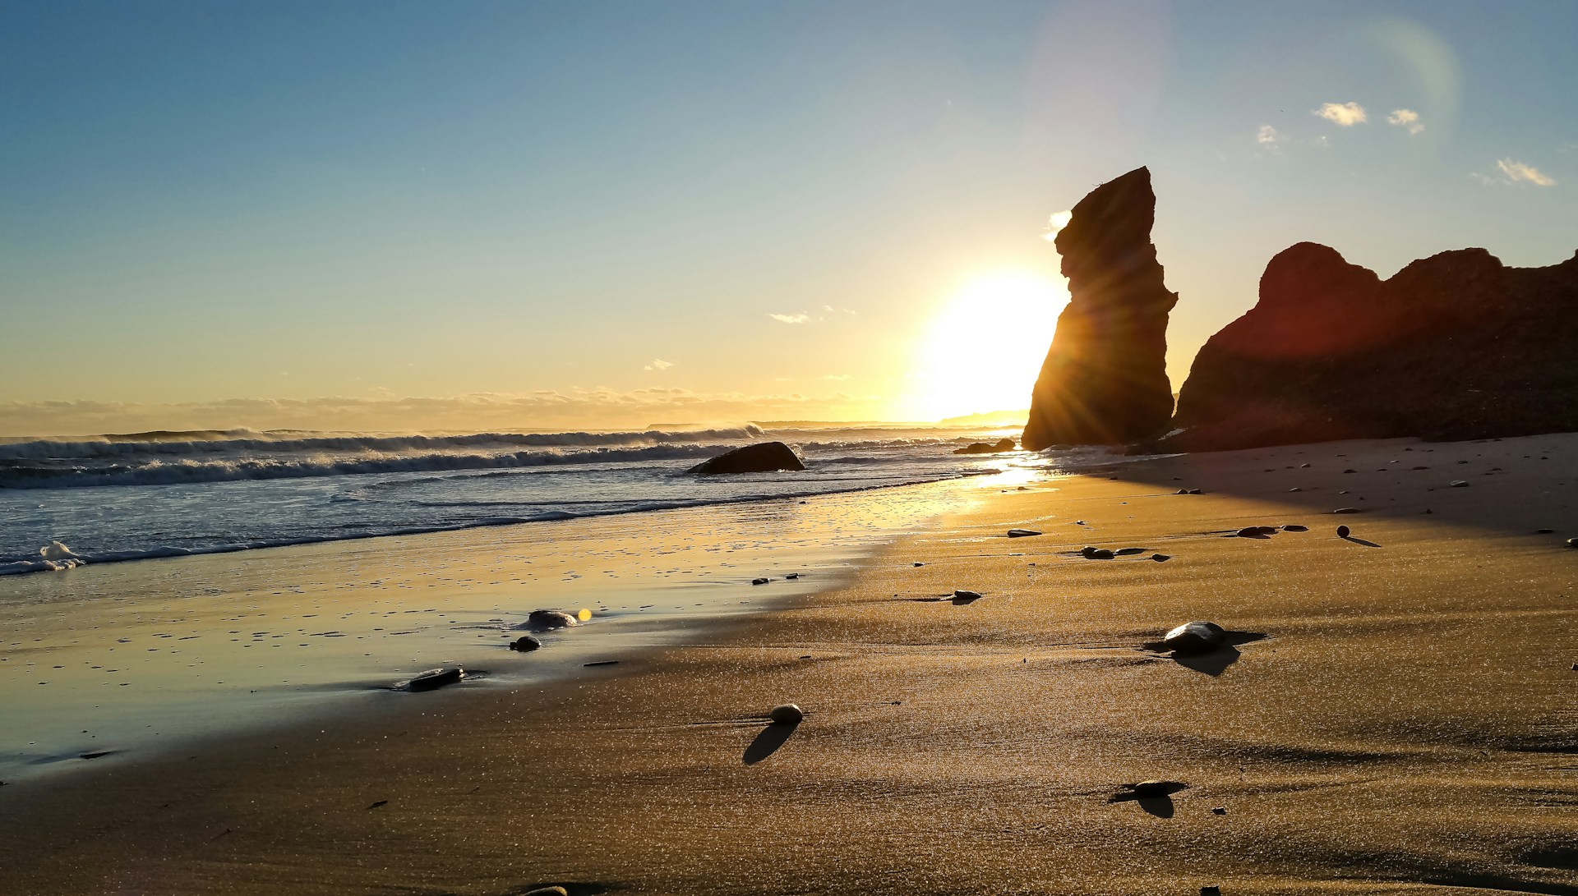

Beach in Chilmark

## 5.2 Elsewhere

The below demonstrates placing more than one image in a gallery. Note the usage of the layout-ncol which arranges the images on the page side by date. Adding the group attribute to the markdown images places the images in a gallery grouped together based upon the group name provided.

|  |  |
| --- | --- |
| Aquinnah  Aquinnah | Oak Bluffs  Oak Bluffs |

|  |
| --- |
| Vineyard lighthouse  Vineyard lighthouse |

## 5.3 With computation code chunks

Options for lightbox can be passed using chunk options.

plot(1:10, rnorm(10))

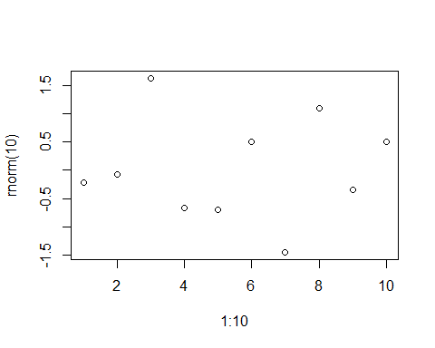

Simple demo R plot

plot(cars)

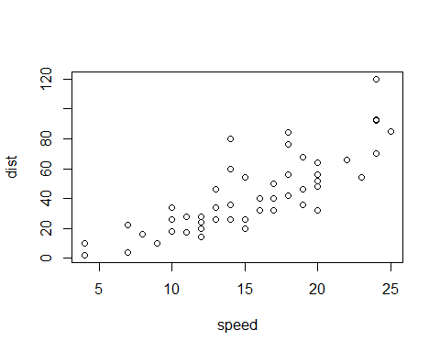

Plot about cars data

It is possible to create several plots, and group them in a lightbox gallery. Use list in YAML for options when you have several plots, on per plot.

plot(mtcars)

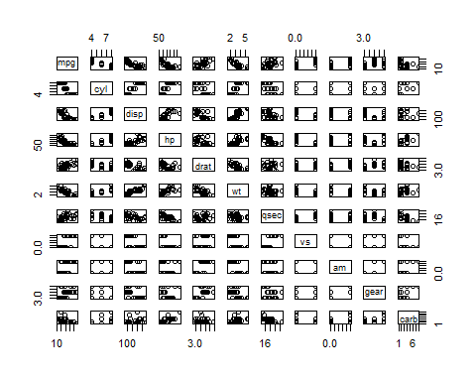

Caption for first plot

plot(cars)



Caption for second plot

When lightbox: auto in main YAML config, you can opt-out lightbox on a plot by setting lightbox: false

plot(mtcars)



mtcars

## 5.4 Credits

The images in this example were used under the [Unsplash license](https://unsplash.com/license), view originals below:

* [Chilmark Beach](https://unsplash.com/photos/VBDJGOMCwps)
* [Aquinnah](https://unsplash.com/photos/2iQnDPLIXwU)
* [Gingerbread House](https://unsplash.com/photos/HQEtvlNzUyA)
* [Edgartown Light](https://unsplash.com/photos/f59MyOfLpi8)
* [Edgartown Sailboat](https://unsplash.com/photos/IiLiz7XpQpI)

# 6. _Przykłady elementów

Poniżej elementy do zastosowania w DSP.

## 6.1 Formatowanie

* **Verbatim code**

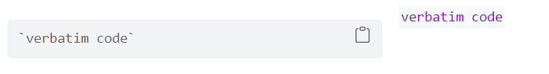

Tu jest verbatim code

* **Term definition**

Term 1

definicja terminu

* **Block quotes**

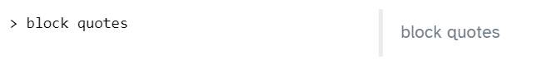

To jest block quotes

* **HTML własny np. odstępy**

<div style="margin-top: 30px;"></div>

* **Podświetlenie tekstu mark**

<mark> To jest zmarkowany tekst </mark>

* **Ukrycie elementu**

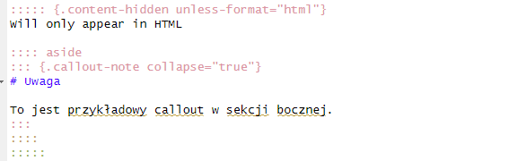

## 6.2 Callouts

* **Podstawowe callouts**

|  |
| --- |
| Caution |
| Tu znajduje się zwijana sekcja w boxie callout typu caution |



|  |
| --- |
| Tip |
| Altair is based on Vega-Lite, a high-level grammar of interactive graphics |



|  |
| --- |
| Note |
| A tu znajduje się callout note |



|  |
| --- |
| This is Important |
| Danger, callouts will really improve your writing. |

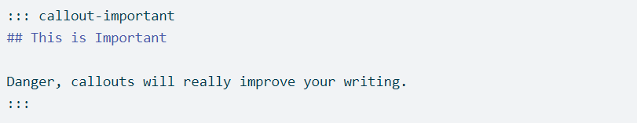

## 6.3 Kolumny

* **Trzy kolumny**

|  |  |  |
| --- | --- | --- |
| This is a template for a simple Quarto book output to html, PDF or docx format. It includes a GitHub Action that will build the website automatically when you make changes to the files. | This is a template for a simple Quarto book output to html, PDF or docx format. It includes a GitHub Action that will build the website automatically when you make changes to the files. | This is a template for a simple Quarto book output to html, PDF or docx format. It includes a GitHub Action that will build the website automatically when you make changes to the files. |

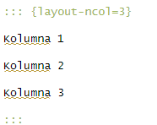

* **Dwie kolumny**

This is a template for a simple Quarto book output to html, PDF or docx format. It includes a GitHub Action that will build the website automatically when you make changes to the files.

This is a template for a simple Quarto book output to html, PDF or docx format. It includes a GitHub Action that will build the website automatically when you make changes to the files.

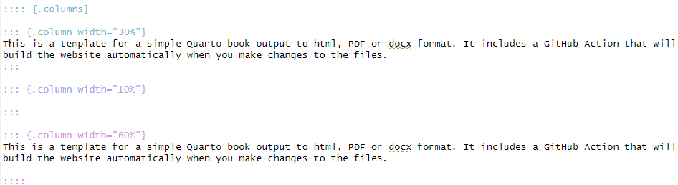

## 6.4 Grafiki

* **Lightbox**



Beach in Chilmark



* **Lightbox grupa**

The below demonstrates placing more than one image in a gallery. Note the usage of the layout-ncol which arranges the images on the page side by date. Adding the group attribute to the markdown images places the images in a gallery grouped together based upon the group name provided.

|  |  |
| --- | --- |
| Aquinnah  Aquinnah | Oak Bluffs  Oak Bluffs |

|  |
| --- |
| Vineyard lighthouse  Vineyard lighthouse |

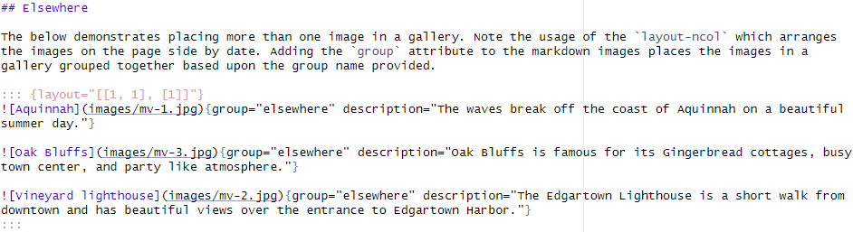

|  |  |  |
| --- | --- | --- |
| Makieta 1  Makieta 1 | Makieta 2  Makieta 2 | Makieta 3  Makieta 3 |

## 6.5 Asides

* **Aside boczne**

By “right format”, we mean that the data is tidy, and ready to be summarised and graphed.



* **Aside boczne callout**

|  |
| --- |
| Uwaga |
| To jest przykładowy callout w sekcji bocznej. |

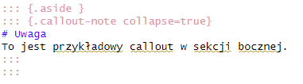

## 6.6 Tabs

* **Tabsy**

### Plots

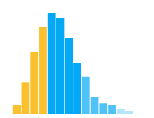

### Data

If you want to allow users to toggle between multiple visualizations, use a tabset (div with class .panel-tabset). Include a heading (e.g. ##) for each tab in the tabset.

For example, here are a plot and data each presented in their own tab.

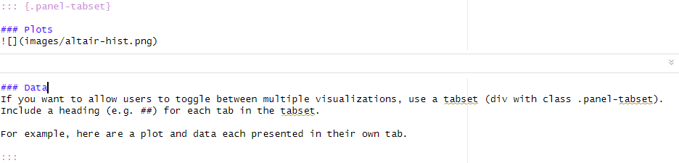

## 6.7 Glossary

Test słowa w słowniku, który jest tu zlikowanyt to We want to define the term data frame in the glossary



a w samym słowniku glossary.qmd definiujesz pojęcie:



# References

Knuth, Donald E. 1984. “Literate Programming.” *Comput. J.* 27 (2): 97–111. <https://doi.org/10.1093/comjnl/27.2.97>.

# Appendix A — Glossary

Console

Coming soon.

Data frame

For our purposes, data frames are just R’s term for data set or data table. Data frames are made up of columns (variables) and rows (observations). In R, all columns of a data frame must have the same length.

Functions

Coming soon.

* **Arguments:** Arguments always go *inside* the parentheses of a function and give the function the information it needs to give us the result we want.
* **Pass:** In programming lingo, you *pass* a value to a function argument. For example, in the funtion call seq(from = 2, to = 100, by = 2) we could say that we passed a value of 2 to the from argument, we passed a value of 100 to the to argument, and we passed a value of 2 to the by argument.
* **Returns:** Instead of saying, “the seq() function *gives us* a sequence of numbers…” we could say, “the seq() function *returns* us a sequence of numbers…” In programming lingo, functions *return* one or more results.

Global environment

Coming soon.

Objects

Coming soon.